**HOME AUTOMATION SYSTEM**

Submitted in partial fulfillment of the requirements for the award of degree of

**BACHELOR OF ENGINEERING**

**IN**

**COMPUTER SCIENCE & ENGINEERING**



**SUBBMITTED BY**

**Ayush Sharma 16BCS1550**

**G.Bheemender 16BCS1043**

**DEPARTMENT OF COMPUTER SCIENCE & ENGINEERING**

**Chandigarh University, Gharuan**

**December 2018**



**CERTIFICATE**

This is to certify **Ayush Sharma and G.Bheemeneder** of **V** Semester, B.E (Computer Science and Engineering) 2016-20, has presented a project report on titled “**HOME AUTOMATION SYSTEM”** in partial fulfillment for the award of the degree of Bachelor of Engineering under Chandigarh University

Date: …………………

**Project Mentor Project Teacher**

**ACKNOWLEDGEMENT**

I express my sincere thanks to my project Mentor Prashant Sir , for guiding me right from the inception till the successful completion of the project. I sincerely acknowledge him for extending their valuable guidance, support for literature, critical reviews of project and the report and above all the moral support she had provided to me with all stages of this project.

A Very Special thanks go out to the Project Teacher (Computer Science and Engineering) Parul Sood mam who has always given a patient hearing to all our doubts and provided useful suggestions for completing the report.

I would also like to thank the supporting staff of Department of CS (Chandigarh University) for their help and cooperation throughout our project.

Ayush Sharma

G.Bheemender

**ABSTRACT**

* IT sector gives us new technologies every day, that technologies change our lifestyle. Now we are entering the emerging world of internet which is called IOT- Internet of Things. IOT is an very interesting and emerging topic of new upcoming technical, social and economic world. From Human to machine, machine to machine, machine to architecture and to the nature, the internet is everywhere. This is the internet of every intelligent thing. IOT is a combination of smart machines communicating and interacting with other machine and make our lives much easier and safer. IOT is a “Universal Global Neural Network”. We can say that in IOT billions of smart things are connected together, which are work together and produce a smart machine or product. The main purpose of this review paper is to provide a comprehensive overview of the Internet of things, architecture and vital technologies and their uses in our new fast growing life, also review its different abilities.
* The main prospective of IOT in Home Automation is to build a smart home device which can be controlled by the internet. IOT devices can used to control and monitor various electrical, mechanical system used in buildings and homes. These system are provide very easy working and control over the devices. We can control our home appliances (AC, Lamps, doors, Machines etc.) by using internet or any software on our Android or any other device, even if we are outside if our home we can watch over these internet of things. One of the main benefits of IOT in home automation is Security; there are several devices which are works for the security of home, like smart Doors, AI Cameras etc. Smart Home has become the revolutionary ladder of success in the residential spaces and it is predicted Smart homes will become as common as smartphones.

**List of Figures**

|  |  |  |
| --- | --- | --- |
| **Figure No.** | **Title** | **Page No.** |
| 1. | DEVELOPMENT DIAGRAM |  |
| 2. | DATA FLOW DIAGRAM |  |
| 3. | CONTEXT FLOW DAIGRAM | . |
| 4. | CURCUIT DAIGRAM | . |

# TABLE OF CONTENTS

CERTIFICATE………………………………………..………………………..…...i

ACKNOWLEDGEMENT ……………………………………………...……….....ii

ABSTRACT…………………………...…………………………………………...iii

LIST OF FIGURES ………………………………………………………………..iv

LIST OF TABLES………………………………………………………..………...v

1. **INTRODUCTION…………………………..……………......................................07-09**

1.1 PURPOSE OF PROJECT ………………………………..…………..………8

1.2 SCOPE OF PROJECT …………….…………….……..……………………...9

1. **GENERAL DESCRIPTION …….…………...………..........................................10-11**

2.1 ABOUT ARDUINO ………………………… ……..……………..................10

2.2 ABOUT RELAY MODULE…………….…………………………….............11

2.3 ABOUT BLUETOOTH………………………………………………………..11

2.4 ABOUT ANDROID APP………… ………………………………….………11

1. **PROJECT MODULES** **…………...…….…..……...………….…........................12-16**

3.1 MODULES ……………………………………...………………………….....12-14

3.2 HARDWARE REQUIREMENT..........................................................................15

3.3 SOFTWARE REQUIREMENT…………………………..………………….… 15

3.4 FUNCTIONAL REQUIREMENTS & SPECIFICATIONS………………...…..16

1. **SYSTEM DESIGN………..…………..……….…..…….......................................17-25**
   * 1. DATABASE DESIGN ………………..…………….....…………………...17
     2. DEVELOPMENT DIAGRAM…………………………………………..…20
     3. DATA FLOW DIAGRAM.…….………..…... …………..………………21
     4. CIRCUIT DAIGRAM/Android App /ACTIVITY DAIGRAM.…….…....23-25
2. **RESULT.……………………...………......…………………..………………………26**
   1. PROJECT SNAPSHOT…………………………………………………..………….26
3. **CONCLUSION………………………………………………………………….…….27**
4. **REFRENCES...……………………………..................................................................28**

CHAPTER -1

**INTRODUCTION**

Homes of the 21st century will become more and more self-controlled and automated due to the comfort it provides, especially when employed in a private home. A home automation system is a means that allow users to control electric appliances of varying kind. Many existing, well-established home automation systems are based on wired communication. This does not pose a problem until the system is planned well in advance and installed during the physical construction of the building. But for already existing buildings the implementation cost goes very high In contrast, Wireless systems can be of great help for automation sys-tems. With the advancement of wireless technologies such as Wi-Fi, cloud networks in the recent past, wireless systems are used every day and everywhere.

The main prospective of IOT in Home Automation is to build a smart home device which can be controlled by the internet. IOT devices can used to control and monitor various electrical, mechanical system used in buildings and homes. These systems are provide very easy working and control over the devices. We can control our home appliances (AC, Lamps, doors, Machines etc.) by using internet or any software on our Android or any other device, even if we are outside if our home we can watch over these internet of things. One of the main benefits of IOT in home automation is Security; there are several devices which are works for the security of home, like smart Doors, AI Cameras etc. Smart Home has become the revolutionary ladder of success in the residential spaces and it is predicted Smart homes will become as common as smartphones.

The aim of proposed system is to develop a system of improved facilities. The proposed system can overcome all the limitations of the existing system. The system provides proper security and reduces the manual work. The existing system has several disadvantages and many more difficulties to work well. The proposed system tries to eliminate or reduce these difficulties up to some extent. The proposed system will help the user to reduce the workload and mental conflict. The proposed system helps the user to work user friendly and he can easily do his jobs without time lagging.

* 1. **PURPOSE OF PROJECT**

In recent years, wireless systems like Wi-Fi and Bluetooth have become more and more common in home networking. Also in home and building automation systems, the use of wireless technologies gives several advantages that could not be achieved using a wired network only. Reduced installation costs: First and foremost, installation costs are significantly reduced since no cabling is necessary. Wired solutions require cabling, where material as well as the professional laying of cables (e.g. into walls) is expensive. System scalability and easy extension: Deploying a wireless network is especially advantageous when, due to new or changed requirements, extension of the network is necessary.

In contrast to wired installations, in which cabling extension is tedious. This makes wireless installations a seminal investment. Aesthetical benefits: Apart from covering a larger area, this attribute helps to full aesthetical requirements as well. Examples include representative buildings with all-glass architecture and historical buildings where design or conservatory reasons do not allow laying of cables. Integration of mobile devices: With wireless networks, associating mobile devices such as PDAs and Smartphones with the automation system becomes possible everywhere and at any time, as a device's exact physical location is no longer crucial for a connection (as long as the device is in reach of the network).

The proposed system is a distributed home automation system, consists of server, sensors. Server controls and monitors the various sensors, and can be easily configured to handle more hardware interface module (sensors). This project is based on the construction of a model simulating a home automation with different operation modes which can be controlled also by a mobile application. To achieve this objective, a scale house that captures different signals, both digital and analog, has been developed. To approach the house to a real home automation application the variables under study and control are lighting home appliances and other electrical objects.

* 1. **SCOPE OF PROJECT**

Here’s a closer look at some of the biggest benefits that home automation provides.

* **Savings:**Smart thermostats and smart light bulbs save energy, cutting utility costs over time. Some home automation technologies monitor water usage, too, helping to prevent exorbitant water bills. Certain devices even offer rebates.
* **Safety:**Many home automation technologies fall under the umbrella of home security. Consumers purchase these devices because they want to make their homes safer and more secure. Automated lighting thwarts would-be burglars, and motion sensors help people enter doors and walk hallways late at night.

*Security cameras offer benefits through either remote monitoring of package deliveries or real-time video of home inhabitants or unwanted visitors.*

* **Convenience:**Because home automation technology performs rote tasks automatically, end users experience great convenience. Lots of smart gadgets are compatible with one another, and you can set different triggers between devices to automate regular home processes. For instance, you could set your smart locks to turn on your smart lighting when you unlock the front door.
* **Control:**Consumers also choose smart home devices to better control functions within the home. With home automation technology, you can know what’s happening inside your home at all times.
* **Comfort:**Some people use smart technology to record shows or to play music throughout the home. Connected devices can also help create a comfortable atmosphere—they provide intelligent and adaptive lighting, sound, and temperature, which can all help create an inviting environment.
* **Peace of Mind:**Finally, many consumers invest in home automation technology for peace of mind. A new mom or dad can check on their little one thanks to smart cameras and other technologies. Or, if you can’t remember whether you closed the garage after you left, you can verify remotely with an app.
* **APPLICATIONS:-**

According to a survey of ABI Research (a market research and market intelligence firm based in New York) there will be more than 40 billon devices which are connected to Internet of things by 2020. As per a recent survey and study done by Pew Research Internet Project, a large majority of the technology experts and engaged Internet users who responded—83 percent—agreed with the notion that the Internet/Cloud of Things, embedded and wearable computing (and the corresponding dynamic systems) will have widespread and beneficial effects by 2025. It is clear that IOT will consist of very large number of devices being connected to the internet. IOT introduce many real world applications that changes the whole scenario of the human lifestyle, now we are connected to machines which are smartly controlled by us using internet or network.

* + **Smart Home: -** The main prospective of IOT in Home Automation is to build a smart home device which can be controlled by the internet. IOT devices can used to control and monitor various electrical, mechanical system used in buildings and homes. These system are provide very easy working and control over the devices. We can control our home appliances (AC, Lamps, doors, Machines etc.) by using internet or any software on our Android or any other device, even if we are outside if our home we can watch over these internet of things. One of the main benefits of IOT in home automation is Security; there are several devices which are works for the security of home, like smart Doors, AI Cameras etc. Smart Home has become the revolutionary ladder of success in the residential spaces and it is predicted Smart homes will become as common as smartphones.

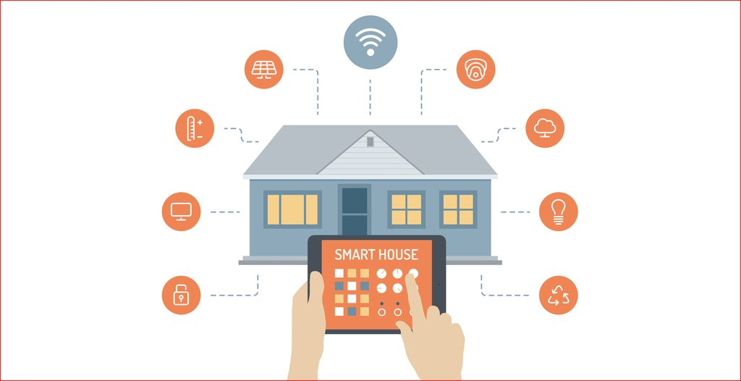

Home Automation

* + **Smart Cities:-** Cities are seeing unprecedented growth, bringing major challenges as they seek to remain sustainable, healthy and safe places for people to live and work. The Internet of Things (IoT) offers new opportunities for cities to use data to manage traffic, cut pollution, make better use of infrastructure and keep citizens safe. smart cities are also a powerful application of IOT generating curiosity among world population. Intelligent and smart surveillance, automatic transportation, smart energy management systems , smart water management system, smart and intelligent machines, new powerful and smart security solutions, environmental monitoring system are some example of smart applications of IOT which help us to make a ordinary city to smart city. IOT is very helpful to solve some major problem of any city, like parking, pollution, increase in traffic, and shortage of energy resources. With the help of IOT application a person is able to find free parking slot across the city. It will also help in waste or trash management i.e. smart alerts are sending to the municipal department about the trash or waste or when a bin needs to be emptied.

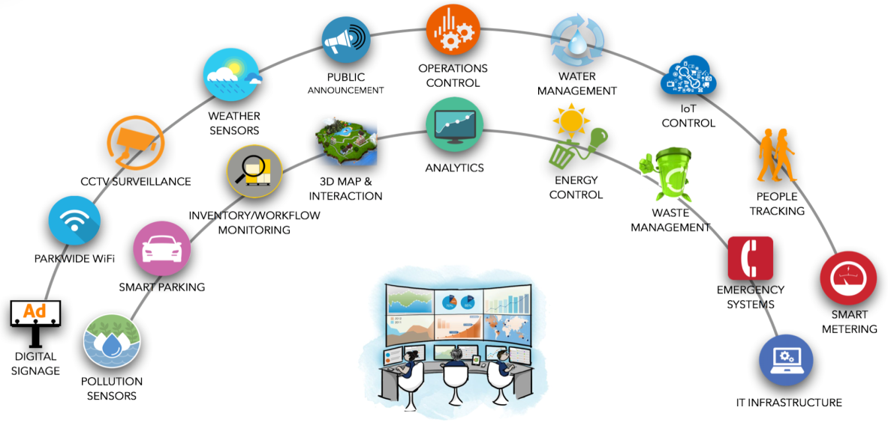

Smart City ( IOT Applications)

* + **Healthcare:-** IOT is partially involved in the field of healthcare. It is still remains the sleeping giant of the Internet of things applications. But with the time and improvement of technologies IOT get involved in the healthcare. According to some research IOT become massive in the field of healthcare. The main motive of IOT in the field of healthcare is to empowering the peoples to live a healthy life. Smart device are made to monitor the daily routine of the person to provide them a proper tips according to their daily life style. IOT has various applications in the field of healthcare from remote monitoring to smart sensors and medical device integration. IOT healthcare application creates a strong bond between patient and doctor. With lots of pros there are some corns also, it is not easy to maintain the large amount of collected data of the patients for Hospital’s IT division, also this data is shared with another devices so security of the data is also a issue with healthcare applications. But with the time IOT is improving in the healthcare sector, we will see tremendous results in upcoming years

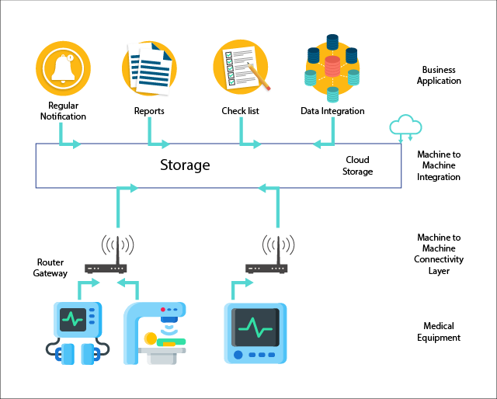

IOT in Healthcare

* + **Agriculture:-** with the increase in population, the demand of raw food is also rapidly increases. Precision agriculture and Smart farming is new and one of the best application of IOT in the field of agriculture. Government encourages the farmers to use the new and smart techniques of farming. The adoption of access to high-speed internet, mobile devices, and reliable, low-cost satellites (for imagery and positioning) by the manufacturer are few key technologies characterizing the precision agriculture trend. The soil moisture probe technology provides complete in-season local agronomy support, and recommendations to optimize water use efficiency. There are some other smart techniques or application provided by IOT for a better farming and agriculture experience like Smart Greenhouse, Agriculture Drone, Livestock Monitoring etc., and these techniques helps a lot to increase the food production to reduce the shortage of raw food across worldwide.

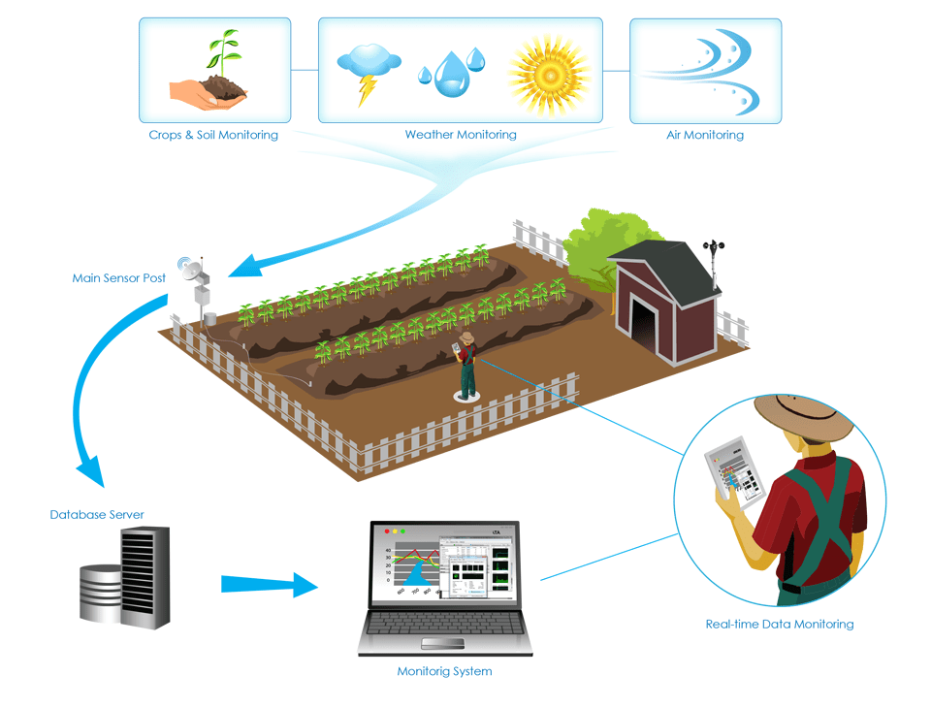

Precision Agriculture system

* + **Industrial Internet:-** We’re in the midst of a significant transformation regarding the way we produce products thanks to the digitization of manufacturing. This transition is so compelling that it is being called[Industry 4.0](https://www.bernardmarr.com/default.asp?contentID=966) to represent the fourth revolution that has occurred in manufacturing. Industrial internet is new buzz in industries, it is also termed as industrial internet of things. Using big data, AI, sensors and software It empower our industries with smart machines. Industrial internet of things holds great potential for quality control and sustainability. Applications for tracking goods, real time information exchange about inventory among suppliers and retailers and automated delivery will increase the supply chain efficiency. There are many fields and application of IIOT in industries like Digital Factory, Facility Management, Production Flow Monitoring, Inventory Management, Plant safety And Security, Quality Control, Packaging Optimization, Logistic And supply chain Management. These all application changes the whole scenario of industry. With the help of IIOT Industries become Smart Industries with a better productivity, quality, approach and safety.

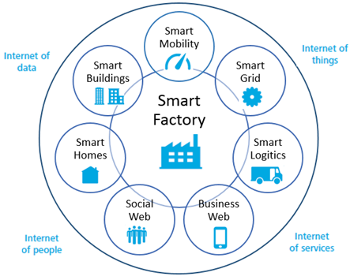

* + **Energy Management:-**  The premise of energy management is controlling elements at a fundamental and granular level. The deeper and tighter the control the better. In a world that is saturated in IOT devices, that control will be quite deep. The billions – and eventually trillions – of sensors and other devices that will create a mesh that will facilitate energy management services and procedures that would have been impossible otherwise. It is expected that IOT devices will be integrated into all forms of energy consuming devices and be able to communicate with the utility supply company in order to effectively balance power generation and energy usage. Power Grid of the future are highly reliable and smart. Smart Grid concept is highly popular in the whole world. The main idea of motive behind smart grid concept is to measure and analyze the consumer behavior and consumption of the energy, to improve the efficiency as well as economic condition of the energy resource. Smart Grids will also be able to detect sources of power outages more quickly and at individual household levels like nearby solar panel, making possible distributed energy system. These systems or application are very useful for saving the electricity and energy resources by using the resources smarty with the help of IOT.

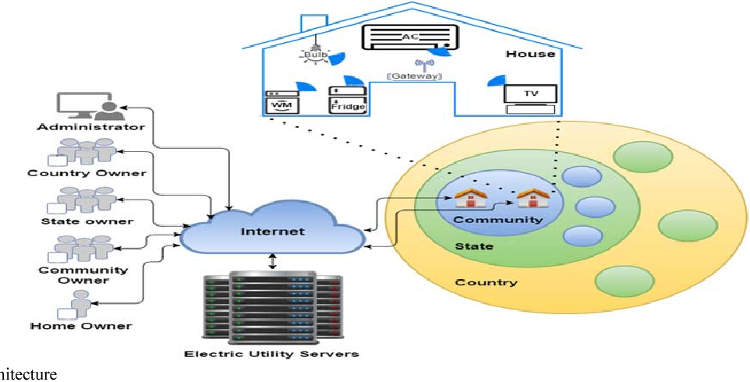

* + **Environmental Monitoring:-** IOT sensors are used to monitor the weather conditions or data of any place. IOT sensor typically assist in environmental protection by monitoring air and water quality, atmosphere and soil conditions, also monitors the wildlife and movements in the area. With the increase in population the environment is degraded day by day, IOT is the way to improve the condition of the environment. There are several application of IOT like smart farming, energy management, using real time data for stop deforestation, internet of bees, connected sensors and camera to stop poaching. Development of resource constrained devices connected to the Internet also means that other applications such as tsunami or earthquake early warning systems can also reported and used by emergency services to provide effective aid.

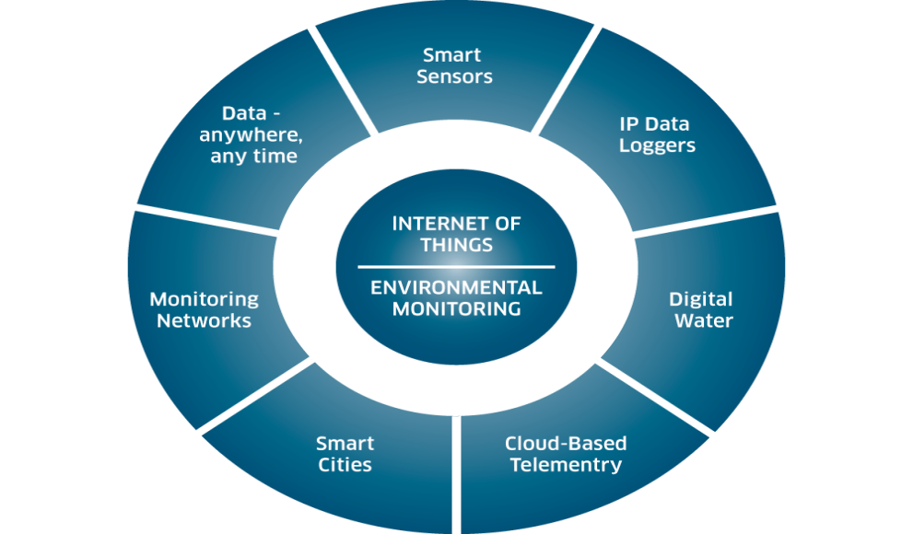

CHAPTER -2

**GENERAL DESCRIPTION**

In this section we can describe all the main languages and software with all their description. To build the Home Automation system we use Arduino Uno Board, Relay Module And Bluetooth Module and Android App. The brief description of different labels is given below:-

* 1. **ABOUT ARDUINO:-**

Arduino is an open-source electronics platform based on easy-to-use hardware and software. Arduino boards are able to read inputs - light on a sensor, a finger on a button, or a Twitter message - and turn it into an output - activating a motor, turning on an LED, publishing something online. You can tell your board what to do by sending a set of instructions to the microcontroller on the board. To do so you use the Arduino programming language (based on Wiring), and the Arduino Software (IDE), based on Processing.Over the years Arduino has been the brain of thousands of projects, from everyday objects to complex scientific instruments.

A worldwide community of makers - students, hobbyists, artists, programmers, and professionals - has gathered around this open-source platform, their contributions have added up to an incredible amount of accessible knowledge that can be of great help to novices and experts alike.

Arduino was born at the Ivrea Interaction Design Institute as an easy tool for fast prototyping, aimed at students without a background in electronics and programming. As soon as it reached a wider community, the Arduino board started changing to adapt to new needs and challenges, differentiating its offer from simple 8-bit boards to products for IoT applications, wearable, 3D printing, and embedded environments.

All Arduino boards are completely open-source, empowering users to build them independently and eventually adapt them to their particular needs. The software, too, is open-source, and it is growing through the contributions of users worldwide.

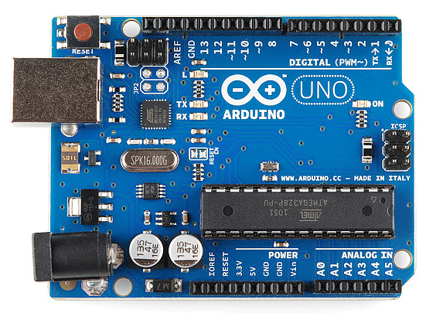

* 1. **ABOUT RELAY MODULE:-**

The relay module is a separate hardware device used for remote device switching. With it you can remotely control devices over a network or the Internet. Devices can be remotely powered on or off with commands coming from Clock Watch Enterprise delivered over a local or wide area network.  You can control computers, peripherals or other powered devices from across the office or across the world.The Relay module can be used to sense external On/Off conditions and to control a variety of external devices. The PC interface connection is made through the serial port.

 A relay is an electrically operated switch. Many relays use an electromagnet to mechanically operate a switch, but other operating principles are also used, such as solid-state relays. Relays are used where it is necessary to control a circuit by a separate low-power signal, or where several circuits must be controlled by one signal. The first relays were used in long distance telegraph circuits as amplifiers: they repeated the signal coming in from one circuit and re-transmitted it on another circuit. Relays were used extensively in telephone exchanges and early computers to perform logical operations. The Relay module houses two SPDT relays and one wide voltage range, optically isolated input.  These are brought out to screw-type terminal blocks for easy field wiring. Individual LED’s on the front panel monitor the input and two relay lines. The module is powered with an AC adapter.

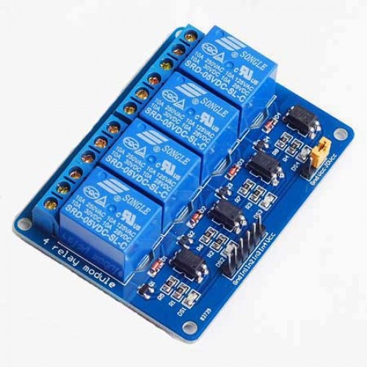

* 1. **ABOUT BLUETOOTH MODULE:-**

Bluetooth HC-05 module is an easy to use Bluetooth SPP (Serial Port Protocol) module, designed for transparent wireless serial connection setup. Serial port Bluetooth module is fully qualified Bluetooth V2.0+EDR (Enhanced Data Rate) 3Mbps Modulation with complete 2.4GHz radio transceiver and baseband. It uses CSR Bluecore 04-External single chip Bluetooth system with CMOS technology and with AFH(Adaptive Frequency Hopping Feature). It has the footprint as small as 12.7mmx27mm. Hope it will simplify your overall design/development cycle.

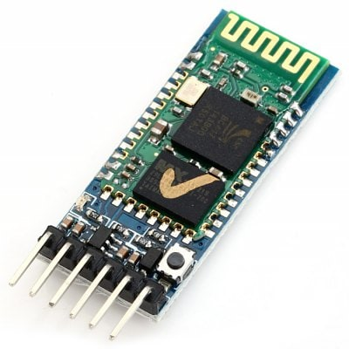

* 1. **ANDROID APP:-**

The app is used to control the activity of the whole system. By connecting the Bluetooth module with this Android App, we can control the Arduino module and Relay Module. This app is Accessible in whole type of Android Devices having Android version 4 and higher.

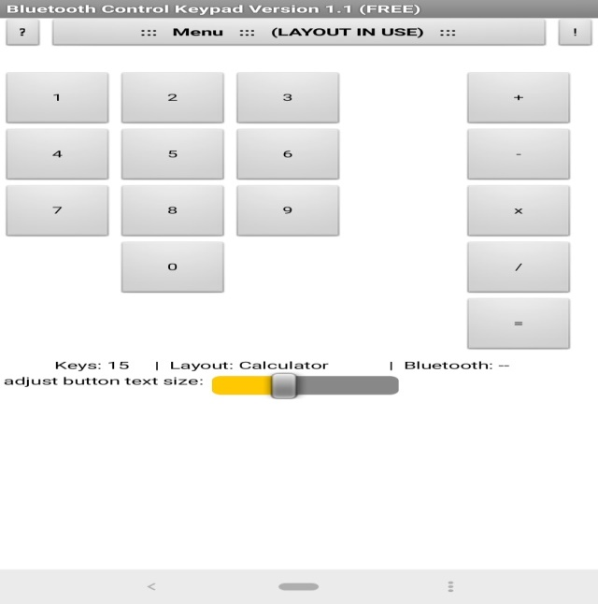

CHAPTER -3

**PROJECT MODULES**

**3.1 Modules**

There is four main stage architecture of an IOT system. The first stage of an IOT system consists of network related things which includes wireless sensors and actuators. The second stage includes the sensor data aggregation system and analog to digital data conversions. In the third stage the data is processed before it moved or delivered to the main data center of cloud storage system, the third stage is called edge computing IT system.  In the fourth stage finally, the data is analyzed, managed and stored in a traditional block of the main data center. Now discuss the four stages in brief.

**3.1.1 Sensor or Actuators:-**

This is the first and the most important stage of the IOT stage Architecture. In this stage, data is collected by the sensors from the environment and objects under measurement and turned into useful data. Sensors and actuators collect user data including sign-on times, level and hours of uses, locations, statistics and many more physical and digital entity or data.  Sensors collect the physical data and process it then sends the digital signals to the control center, further these processed signals are sending to the actuators and the desired task will be performed. Actuators take the electrical input and transform the input into tangible desired action.

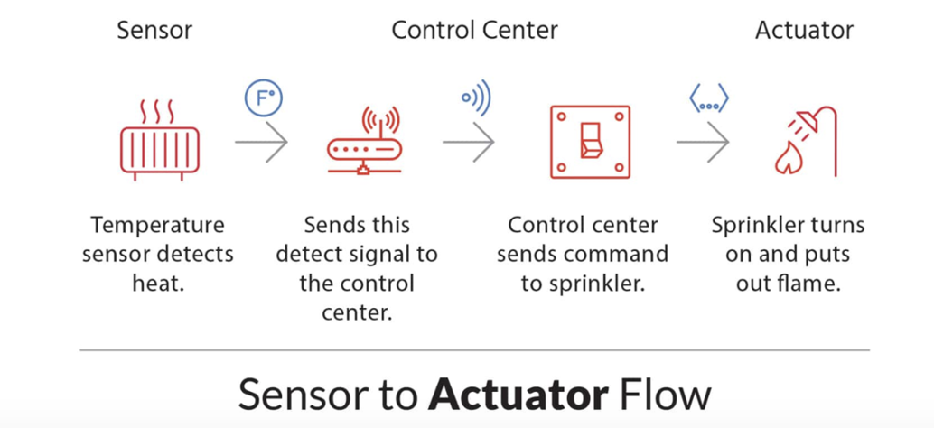

**3.1.2 Internet Gateway and Data Aggressions:-**

Internet Gateway is a physical device or a software program which works as a medium between cloud and controller or any sensor and intelligent device and Data aggregation is the process in which information is gathered and expressed in the summaries form for particular use such as statistical analytics All the data transferred to the cloud or vice versa goes through the Internet gateway. The data which is collected by sensors is very big and needs to be prepared before it entered in the next data processing stage. Mainly the data which is collected is in analog form and it needs to be aggregated and converted into digital form, and this layer does exactly that with the help of an Internet gateway that routes it over WLANs or other networks for further processing. One of the main benefits of Internet Gateway is that it provides additional security for the IOT network and the data that is transported through the internet gateway.

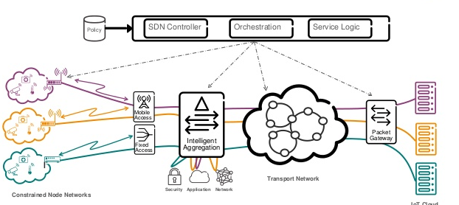

**3.1.3 Edge Computing And IT System:**

Edge: Enabling real-time monitoring, incident management, analysis and asset utilization for smaller, distributed data centers that are becoming more and more critical in an IOT world. The pre – processed data further enters into edge computing it system to perform the analysis of the data. Usually, the IOT data is so enormous that, if directly sent to the data center or server, it can eat up much amounts of network bandwidth, swamping the resources.

Thus, systems at the edge perform analytics to lessen the burden on core IT infrastructure. Edge computing is focused on devices and technologies that are attached to the things in the internet of things. The growing no of IOT devices and dependency on IOT devices, the need of faster processing, the increase in cloud adoption and increase in pressure on network drive the edge computing market. IOT Edge become smarter, Smaller and efficient

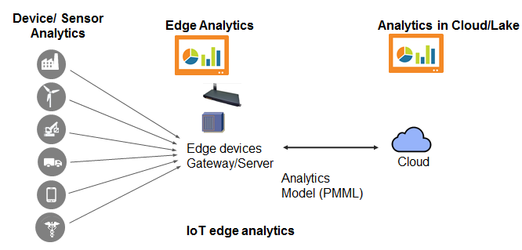

**3.1.4. Data Center And Cloud:-**

It is the finale layer or process of the IOT architecture. A data center is a facility that centralizes an organization's IT operations and equipment, as well as where it stores, manages, and disseminates its data. Data centers house a network's most critical systems and are vital to the continuity of daily operations.This is one of the main stages of the IOT system, in this stage the data is managed analyzed and stored in cloud and IT systems. This layer is responsible for delivering application specific service to the user. Once the data has been analyzed, summarized and organized the information can be fed to the server and applied to the products and the services. Data center provide a optimized storage, security to the data and privacy to the data.

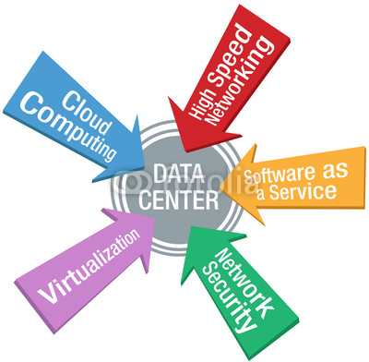

**3.2 Hardware Requirements**

* Arduino Uno
* Relay Module (4 Chips)
* Bluetooth Module
* Jumper Cables

**3.3 Software Requirements**

* Arduino Software (IDE)
* Arduino Compiler
* Android Studio
* Sublime Text Editor

**3.4 FUNCTIONAL REQUIREMENTS & SPECIFICATIONS**

In this project various functions are working. Every function have their own specific meaning and purpose. This whole project is working online and This project is run in action listener events.

**3.4.1 System Features:-**

1. Intel core i3 or higher version.
2. RAM 1GB or higher.
3. HDD space 1-2 GB

**3.4.2 Front end requirements:-**

* Arduino Uno
* Relay Module (4 Chips)
* Bluetooth Module
* Jumper Cables

**3.4.3 Back end requirements:-**

* Arduino Software (IDE)
* Arduino Compilng Language (Node JS, JavaScript)
* Android Studio
* Sublime Text Editor

CHAPTER - 4

**SYSTEM DESIGN**

**4.1 ARDUINO PROGRAMING**

As a global overview of Arduino programming, it is divided, as established in the IDE code development, in two main parts: setup and loop functions. The first is the function that is executed only the first time that application runs, instead the second one is executed as a loop, continuously.

For this application additional functions are included to segment and make the program more efficient. There is a function for each mode of function that includes the necessary control loops. At the beginning of the Arduino code all the components are delimited: type, the pin to which is associated and the operation mode. In addition, it is also declared the global variables and the libraries which will be used in the whole code

**SOURCE CODE:-**

int var;  
#define r1 8  
#define r2 9  
#define r3 10  
#define r4 11  
int a,b,c,d;  
void setup()  
{  
  pinMode(r1,OUTPUT);  
  pinMode(r2,OUTPUT);  
  pinMode(r3,OUTPUT);  
  pinMode(r4,OUTPUT);  
  digitalWrite(r1,HIGH);  
  digitalWrite(r2,HIGH);  
  digitalWrite(r3,HIGH);  
  digitalWrite(r4,HIGH);  
a=1;  
b=1;  
c=1;  
d=1;  
  
  Serial.begin(9600);  
 }  
  
  void loop()  
  {  
    if(Serial.available())  
    {  
      var=Serial.read();  
      switch(var)  
      {  
        case '1':  
        {  
        if(a!=0)  
        {  
        digitalWrite(r1,LOW);  
        a=0;  
        break;  
        }  
        else  
        {a=1;  
        digitalWrite(r1,HIGH);  
        break;  
        }  
        break;  
        }  
  
        case '2':{  
        if(b!=0){  
        digitalWrite(r2,LOW);  
        b=0;  
        break;  
        }  
          
        else{  
          b=1;  
        digitalWrite(r2,HIGH);  
        break;  
        }

}  
          
        case '3':{  
        if(c!=0)  
        {c=0;  
        digitalWrite(r3,LOW);  
        break;  
        }  
        else   
        {c=1;  
          digitalWrite(r3,HIGH);  
          break;  
          }}  
        case '4':{  
        if(d!=0)  
        {d=0;  
        digitalWrite(r4,LOW);  
        break;  
        }  
        else  
        {d=1;  
        digitalWrite(r4,HIGH);  
        break;  
          }  
        }  
      }  
    }

}

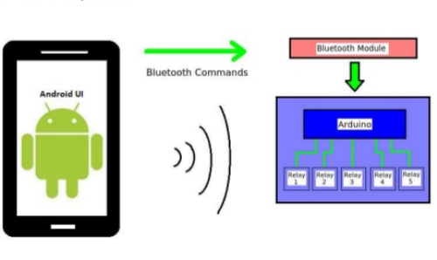

The main objective of this project is to develop a home automation system with Android application controlled remote. As technology is advancing so houses are also getting smarter. Modern houses are gradually shifting from conventional switches to centralized control system, involving wireless controlled switches. Presently, conventional wall switches located in different parts of the house makes it difficult for the user to go near them to operate. Even more it becomes more difficult for the elderly or physically handicapped people to do so. Remote controlled home automation system provides a simpler solution with Android application technology.  
Remote operation is achieved by any smart-phone/Tablet etc., with Android OS, upon a GUI (Graphical User Interface) based touch screen operation. In order to achieve this, Android application act as transmitter, which sends ON/OFF commands to the receiver where loads are connected. By operating the specified remote switch on the transmitter, the loads can be turned ON/OFF remotely through wireless technology. The microcontroller used here is of 8051 family. The loads are interfaced to the microcontroller using Opto-isolators and TRIAC’s.

A database is an organized mechanism that has the capability of storing information through which a user can retrieve stored information in an effective and efficient manner. The data is the purpose of any database and must be protected.

The database design is a two level process. In the first step, user requirements are gathered together and a database is designed which will meet these requirements as clearly as possible. This step is called Information Level Design and it is taken independent of any individual DBMS.

In the second step, this Information level design is transferred into a design for the specific DBMS that will be used to implement the system in question. This step is called Physical Level Design, concerned with the characteristics of the specific DBMS that will be used. A database design runs parallel with the system design. The organization of the data in the database is aimed to achieve the following two major objectives.

* Data Integrity
* Data independence

Normalization is the process of decomposing the attributes in an application, which results in a set of tables with very simple structure. The purpose of normalization is to make tables as simple as possible. Normalization is carried out in this system for the following reasons.

* + To structure the data so that there is no repetition of data , this helps in

saving.

* + To permit simple retrieval of data in response to query and report request.
  + To simplify the maintenance of the data through updates, insertions, Deletions.
  + To reduce the need to restructure or reorganize data which new application

Requirements arise

**4.1.1 Data Flow Diagram**

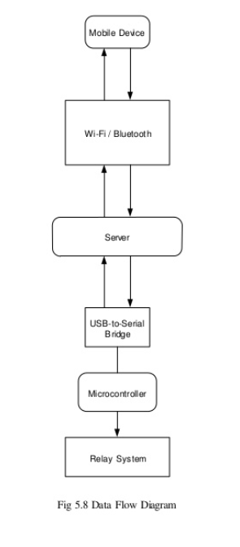

**4.1.2 Flow diagram :-**

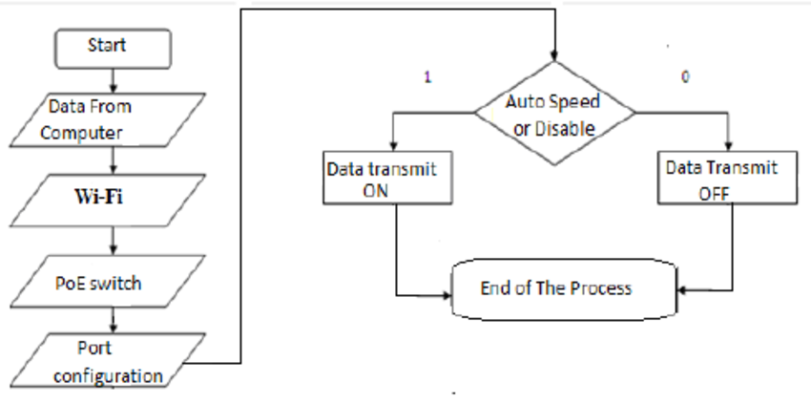

**4.1.3 Circuit Diagram**

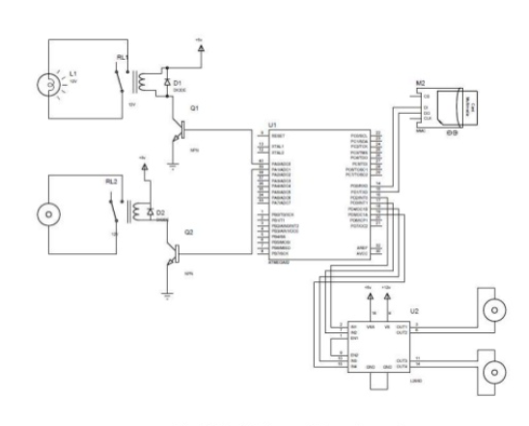

**4.1.4 Activity Diagram**

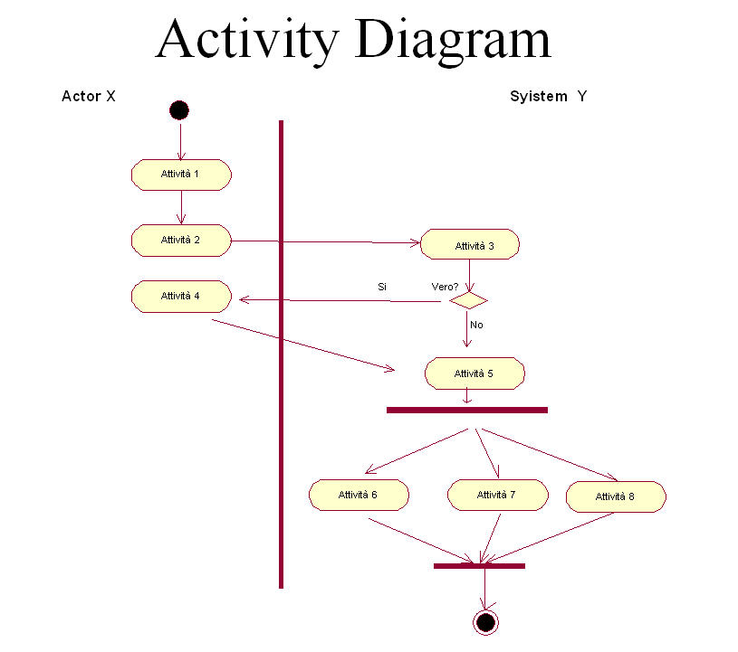

**Smart Home**



**Android App Layout:-**



CHAPTER - 5

**RESULT**

The project report entitled “HOME AUTOMATION SYSTEM has come to its final stage. The system has been developed with much care that it is free of errors and at the same time it is efficient and less time consuming. The entire system is secured. The Electronics gagetes of the house are controlled by the android application over a Bluetooth network, which is operated by user.

A model house is built for the home automation system and is as shown in the figure . At the Light 1 will turn on automatically when light sensor detects the signal from the user end. A cooler/Fan will turn on when the user set the command for the 2nd realy module port. The. The Arduino Uno is connected with Bluetooth Module HC-05 with the antennas for the connectivity with internet and Android App

* 1. **PROJECT SNAP SHOT:-**

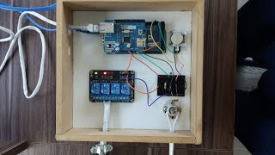

CHAPTER - 6

**CONCLUSION**

The home automation using Internet of Things has been experimentally proven to work satisfactorily by connecting simple appliances to it and the appliances were successfully controlled remotely through internet. The designed system not only monitors the sensor data, like temperature, gas, light, motion sensors, but also actuates a process according to the requirement, for example switching on the light when it gets dark. This will help the user to analyze the condition of various parameters in the home anytime anywhere.

Future work: Using this system as framework, the system can be expanded to include various other options which could include home security feature like capturing the photo of a person moving around the house and storing it onto the cloud. This will reduce the data storage than using the CCTV camera which will record all the time and stores it. The system can be expanded for energy monitoring, or weather stations. This kind of a system with respective changes can be implemented in the hospitals for disable people or in industries where human invasion is impossible or dangerous, and it can also be implemented for environmental monitoring..

CHAPTER - 7

**REFRENCES**

[1]. <https://en.wikipedia.org/wiki/IOT>

[2]. [https://www.tutorialspoint.com/](https://www.tutorialspoint.com/php/index.htm)

[3]. <https://Arduino.com/>

[4]. <https://en.wikipedia.org/Home_automation/>

[[5] https://www.w3schools.com/Json](%5b5%5d%20https://www.w3schools.com/Json)